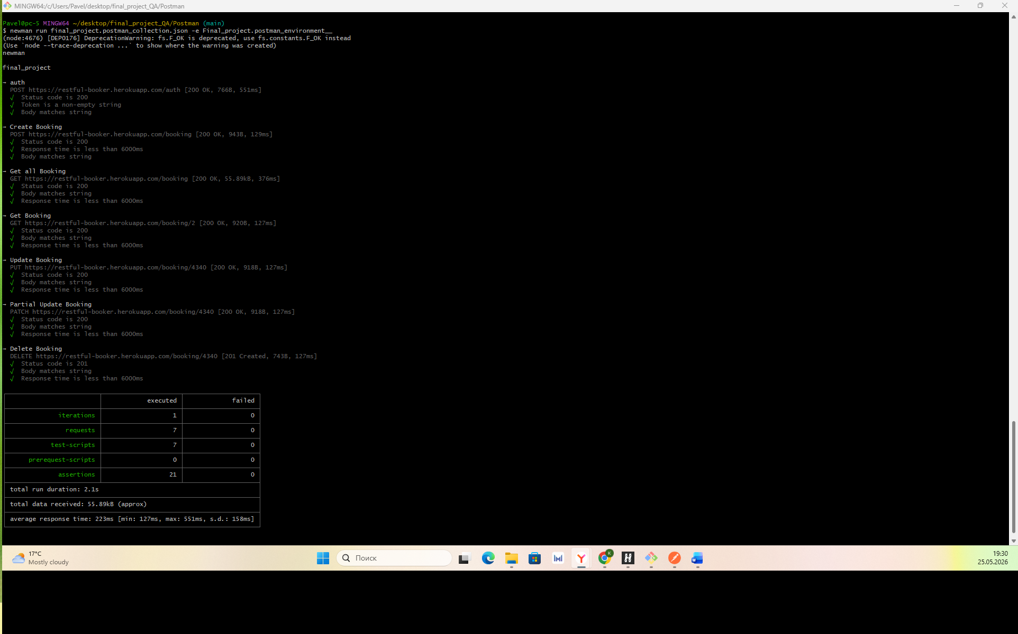

newman run final_project.postman_collection.json -e Final_project.postman_environment__
(node:4676) [DEP0176] DeprecationWarning: fs.F_OK is deprecated, use fs.constants.F_OK instead
(Use `node --trace-deprecation ...` to show where the warning was created)
newman

final_project

→ auth
POST https://restful-booker.herokuapp.com/auth [200 OK, 766B, 551ms]
√ Status code is 200
√ Token is a non-empty string
√ Body matches string

→ Create Booking
POST https://restful-booker.herokuapp.com/booking [200 OK, 943B, 129ms]
√ Status code is 200
√ Response time is less than 6000ms
√ Body matches string

→ Get all Booking
GET https://restful-booker.herokuapp.com/booking [200 OK, 55.89kB, 376ms]
√ Status code is 200
√ Body matches string
√ Response time is less than 6000ms

→ Get Booking
GET https://restful-booker.herokuapp.com/booking/2 [200 OK, 920B, 127ms]
√ Status code is 200
√ Body matches string
√ Response time is less than 6000ms

→ Update Booking
PUT https://restful-booker.herokuapp.com/booking/4340 [200 OK, 918B, 127ms]
√ Status code is 200
√ Body matches string
√ Response time is less than 6000ms

→ Partial Update Booking
PATCH https://restful-booker.herokuapp.com/booking/4340 [200 OK, 918B, 127ms]
√ Status code is 200
√ Body matches string
√ Response time is less than 6000ms

→ Delete Booking
DELETE https://restful-booker.herokuapp.com/booking/4340 [201 Created, 743B, 127ms]
√ Status code is 201
√ Body matches string
√ Response time is less than 6000ms

┌─────────────────────────┬─────────────────────┬────────────────────┐
│ │ executed │ failed │
├─────────────────────────┼─────────────────────┼────────────────────┤
│ iterations │ 1 │ 0 │
├─────────────────────────┼─────────────────────┼────────────────────┤
│ requests │ 7 │ 0 │
├─────────────────────────┼─────────────────────┼────────────────────┤
│ test-scripts │ 7 │ 0 │
├─────────────────────────┼─────────────────────┼────────────────────┤
│ prerequest-scripts │ 0 │ 0 │
├─────────────────────────┼─────────────────────┼────────────────────┤
│ assertions │ 21 │ 0 │
├─────────────────────────┴─────────────────────┴────────────────────┤
│ total run duration: 2.1s │
├────────────────────────────────────────────────────────────────────┤
│ total data received: 55.89kB (approx) │
├────────────────────────────────────────────────────────────────────┤
│ average response time: 223ms [min: 127ms, max: 551ms, s.d.: 158ms] │
└────────────────────────────────────────────────────────────────────┘

